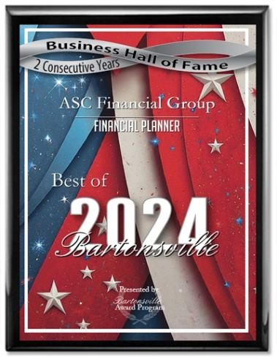Press Release

FOR IMMEDIATE RELEASE

**ASC Financial Group Receives 2024 Best of Bartonsville Award**

Bartonsville Award Program Honors the Achievement

BARTONSVILLE June 12, 2024 -- ASC Financial Group has been selected for the 2024 Best of Bartonsville Award in the Financial Planner category by the Bartonsville Award Program.

Each year, the Bartonsville Award Program identifies companies that we believe have achieved exceptional marketing success in their local community and business category. These are local companies that enhance the positive image of small business through service to their customers and our community. These exceptional companies help make the Bartonsville area a great place to live, work and play.

Various sources of information were gathered and analyzed to choose the winners in each category. The 2024 Bartonsville Award Program focuses on quality, not quantity. Winners are determined based on the information gathered both internally by the Bartonsville Award Program and data provided by third parties.

# About Bartonsville Award Program

The Bartonsville Award Program is an annual awards program honoring the achievements and accomplishments of local businesses throughout the Bartonsville area. Recognition is given to those companies that have shown the ability to use their best practices and implemented programs to generate competitive advantages and long-term value.

The Bartonsville Award Program was established to recognize the best of local businesses in our community. Our organization works exclusively with local business owners, trade groups, professional associations and other business advertising and marketing groups. Our mission is to recognize the small business community's contributions to the U.S. economy.

SOURCE: Bartonsville Award Program

CONTACT: Bartonsville Award Program  
Email: PublicRelations@citiesaccoladebusinesses.com  
URL: <http://www.citiesaccoladebusinesses.com>

**Investment advisory services offered through Brookstone Capital Management, LLC (BCM), a registered investment advisor. BCM and ASC Financial Group are independent of each other. Insurance products and services are not offered through BCM but are offered and sold through individually licensed and appointed agents.**

**Third party ratings and recognitions are no guarantee of future investment success and do not ensure that a client or prospective client will experience a higher level of performance or results. These ratings should not be construed as an endorsement of the advisor by any client nor are they representative of any one client's evaluation.**